Soumya R

9964534149

SQL

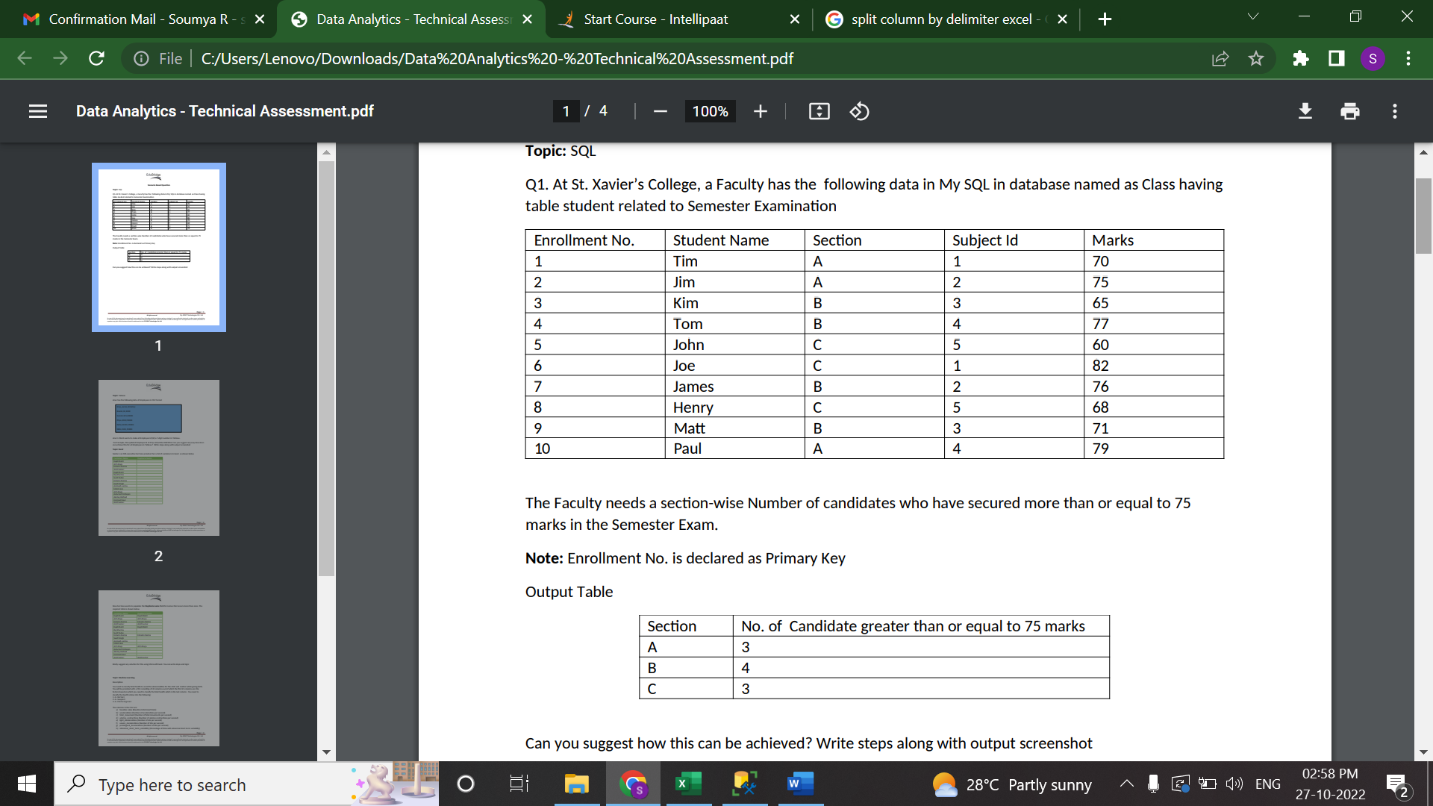

As per the question, the output should have the following results

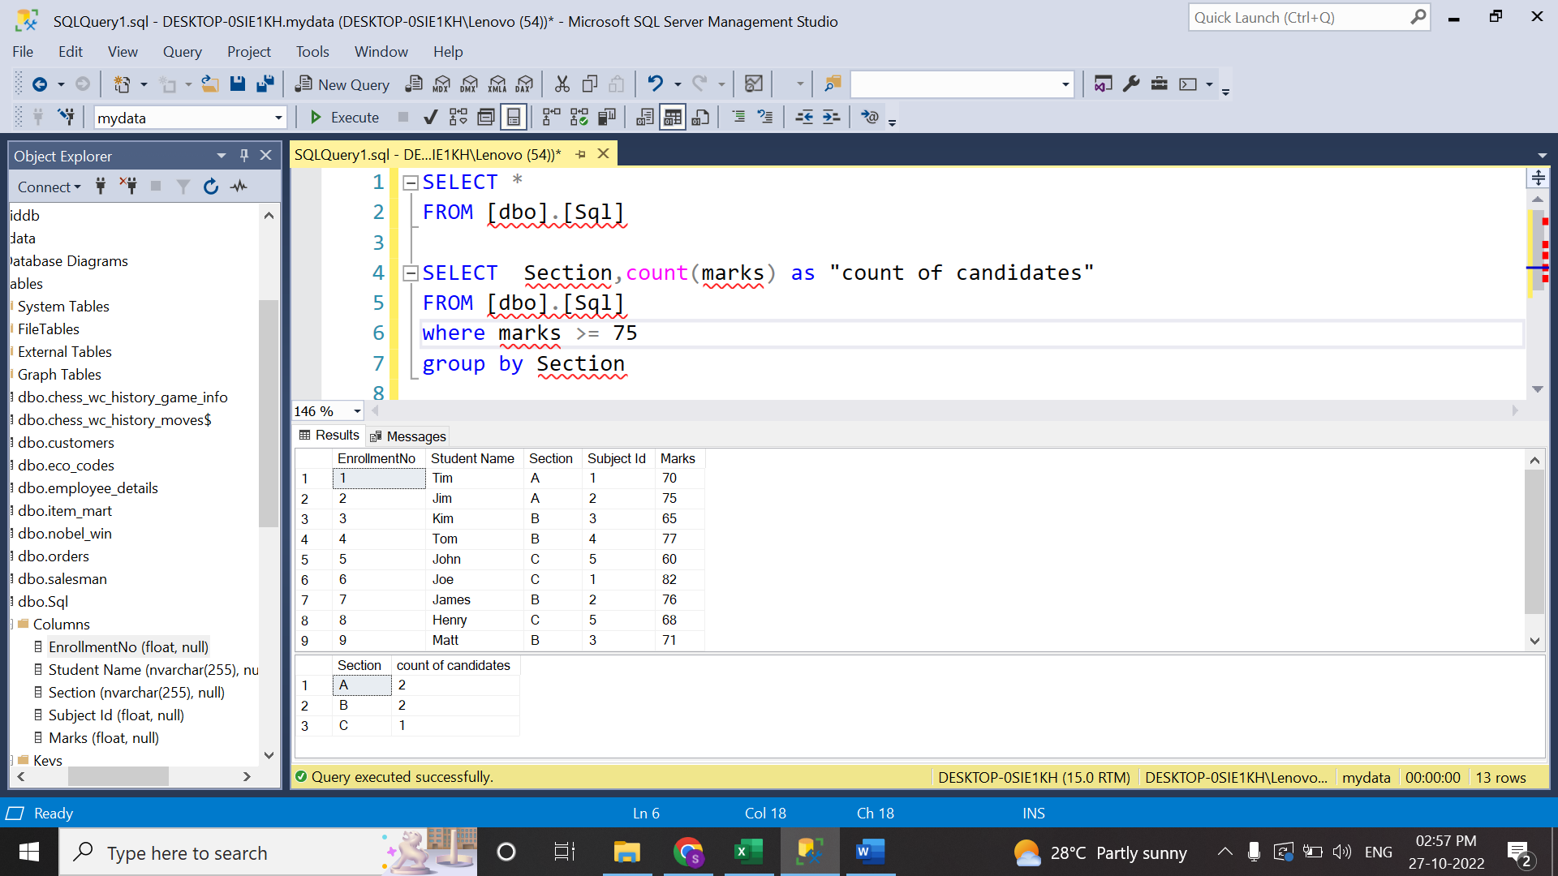

Tableau

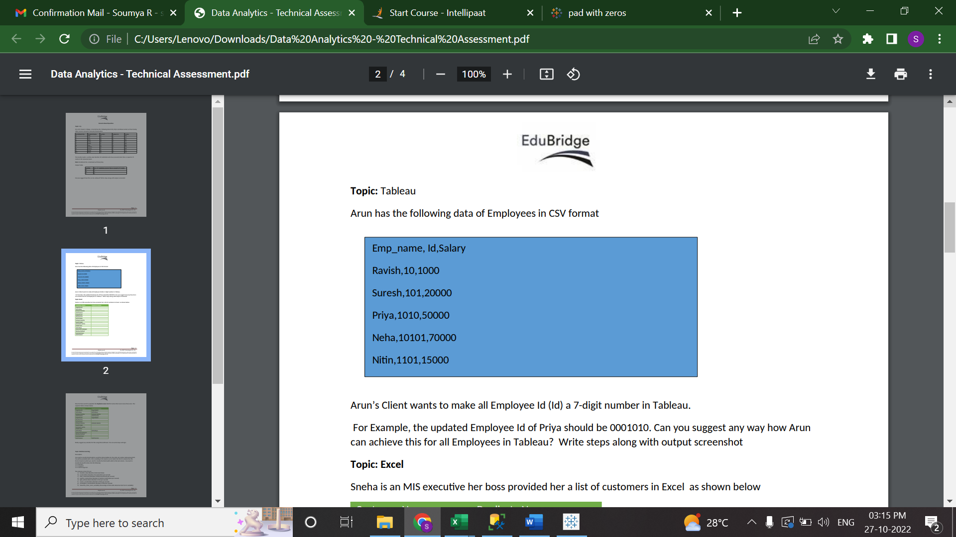

Steps:

1.import the csv file to Tableau

2.Drop Emp Name and Id to rows

3. Right click on Id, go to format

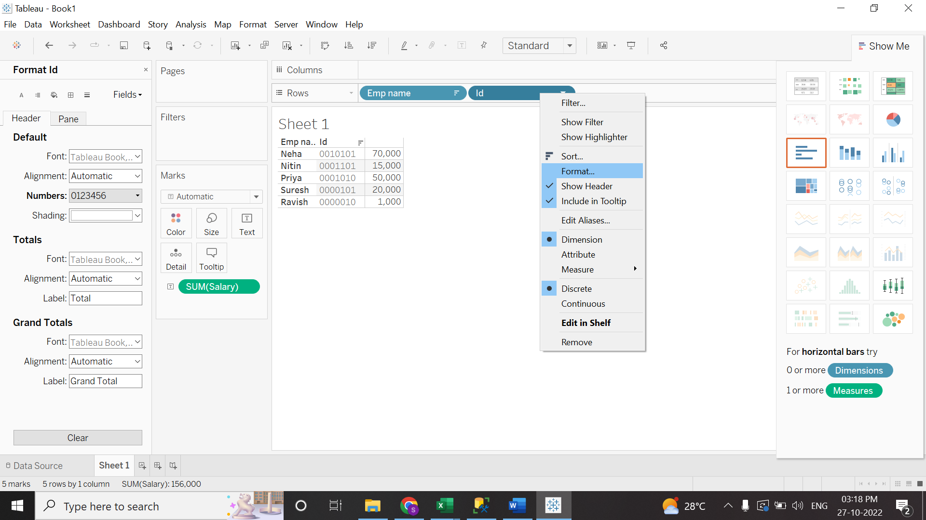

4. Format Id opens at the left

5.under pane, go to numbers and select custom and change the format as shown below to make the ID to 7 digit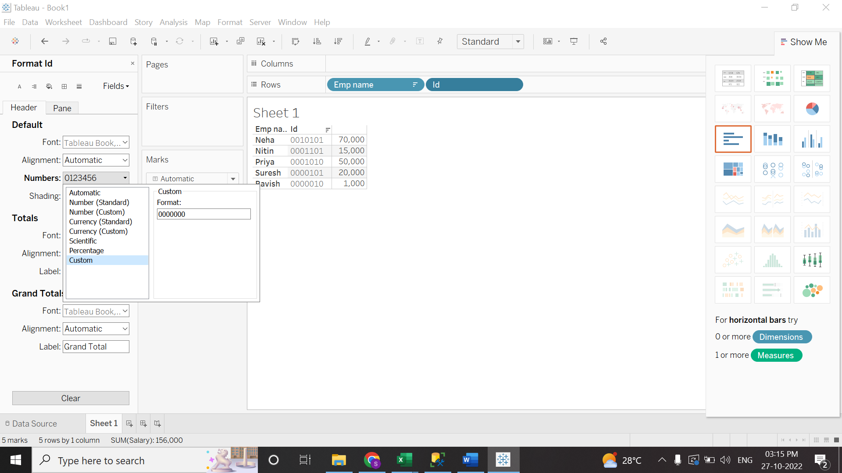

Excel



Machine Learning

Jupyter notebook “FetlalHealth” has the python code

The result is available in CSV files

Result_logreg and result_rf